**Historical Understandings (SS5H1):**

**Cattle trails:**

Many cattle trails began in the state of _________________. Millions of cattle were moved on the __________________ Trail and _____________ _________________ ______________ Trail. ____________ ________________ were former slaves who began ranching cattle after the Civil War. They were treated with ________________ (less/more) discrimination from other cowboys. There was a lot of money to be made in the cattle trade. Cowboys moved their cattle to the north and east on the railroad because the ____________________ was high for beef and they could sell it for _____________ (more/less) money on the east coast.

**Immigration:**

Name the main reasons people immigrated to the United States. ________________________

__________________ entered the US through Ellis Island on the east coast.

__________________ entered the US through the west coast since it were closer to them.

Companies hired immigrants because ______________________________________________

**Spanish-American War:**

The ship called the _____________________________________ exploded. This led to the ______________ _____________War. After the war, the United States became a world power by defeating ______________________. The US also claimed the new territories of _____________________, ______________________, and _______________________. Cuba became _______________________________.

**Inventors:** List the inventor next to each important invention.

_______________________________created over 300 uses for peanuts and taught a new way to farm.

_______________________________invented the electric lightbulb allowing for factories and shops to stay open at night.

_______________________________gave us telephones making it easier to keep in touch and do business with others.

___________________________________invented the first successful airplane.

These inventions changed lives because_____________________________________________ __________________________________________________________________________________________________________________________________________________________

**Geographic Understandings (G1):**

Find Kitty Hawk on the map. Draw and label the cattle trails:

*(Wright Brothers 1st flight)*

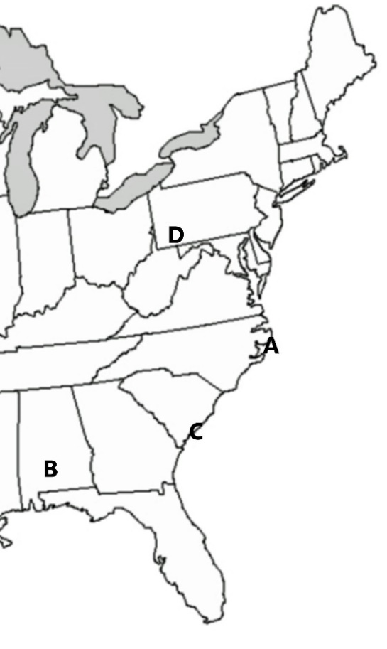



How would a city with lots of railroads help businesses?

________________________________________________________________________________________________________________________________________________________________________________________________________________________________________________________________________________________________________________________________________________________________________________________________________

**Historical Understandings (SS5H1):**

**Cattle trails:**

Many cattle trails began in the state of Texas. Millions of cattle were moved on the Chisholm Trail and Great Western Cattle Trail. Black Cowboys were former slaves who began ranching cattle after the Civil War. They were treated with less (less/more) discrimination from other cowboys. There was a lot of money to be made in the cattle trade. Cowboys moved their cattle to the north and east on the railroad because the demand was high for beef and they could sell it for more (more/less) money on the east coast.

**Immigration:**

Name the main reasons people immigrated to the United States: religious freedom, earn money/jobs, political asylum

**Spanish-American War:**

Europeans entered the US through Ellis Island on the east coast.

Asians entered the US through the west coast since it were closer to them.

Companies hired immigrants because they would work for long hours for low wages.

The ship called the USS Maine exploded. This led to the Spanish American War. After the war, the United States became a world power by defeating Spain. The US also claimed the new territories of Philippines, Guam and Puerto Rico. Cuba became independent.

**Inventors:** List the inventor next to each important invention.

George Washington Carver created over 300 uses for peanuts and taught a new way to farm.

Thomas Edison invented the electric lightbulb allowing for factories and shops to stay open at night.

Alexander Graham Bell gave us telephones making it easier to keep in touch and do business with others.

The Wright Brothers invented the first successful airplane.

These inventions changed lives because people could do more work in less time.

**Geographic Understandings (G1):**

Find Kitty Hawk on the map. Draw and label the cattle trails:

*(Wright Brothers 1st flight)*





1= Great Western Trail

2= Chisholm Trail

A – Kitty Hawk, NC

2

1



How would a city with lots of railroads help businesses?

Lots of railroads would help businesses by transporting goods in and out of the city making it easier to sell or purchase items.